**Established in 1997,** SESI is a seasoned contractor specializing in alternative fuels with vast expertise in renewable fuels, electric, hybrid, natural gas, and high-efficiency vehicle technologies. As the world embraces alternative energy sources, we excel in supporting emerging industries. With three decades of experience, our skilled team is equipped to assist you access federal, state, and non-profit funding opportunities.

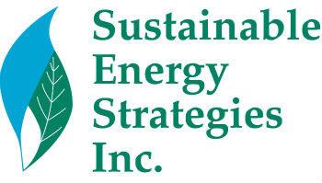

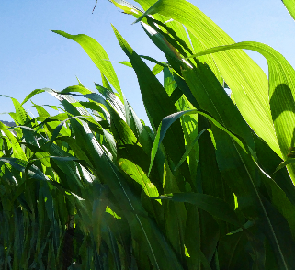**

* Project Development, Management, & Review
* Technical Analysis
* Legislative, Regulatory, Policy & Program Analysis
* Infrastructure Development for Alternative fuels
* Grant Writing, Selection, & Review
* Industry Fundraising
* Public Relations
* Event Coordination

Our Services Include

* 

**Expertise**

* Fundraising and business development experts in alternative fuel vehicles and fuels (natural gas, propane, electric/hybrid, ethanol, biodiesel/renewable blends), with connections to organizations involved in advanced fuel development.
* Long-term familiarity with government, foundation and fund procurement systems. We navigate these systems proficiently to maximize funding opportunities.
* Skilled in foundation management, including

compliance oversight, board coordination, web management, outreach activities, and other

administrative functions.

* Provide comprehensive support for Clean Cities

Coalitions, encompassing training, alternative

fuel infrastructure planning, education and

outreach, policy recommendations, and

project management.

4803 Marymead Drive

Fairfax, VA 22030

[www.sesi-online.com](http://www.sesi-online.com)

**(703)322-4484**

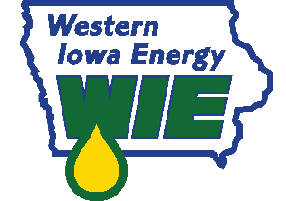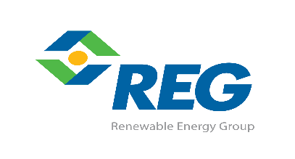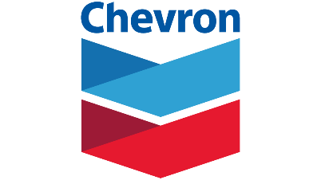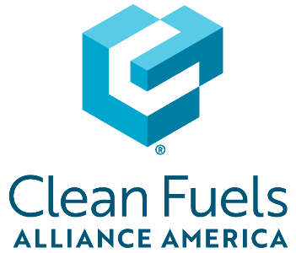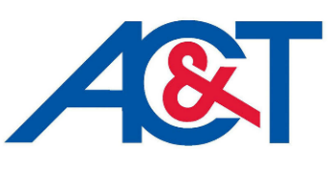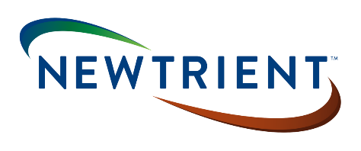***

**Clients include:**

For more information about **SESI** visit [**www.sesi-online.com**](http://www.sesi-online.com) or contact:

**Jill Hamilton,** President

([jhamilton@sesi-online.com](mailto:jhamilton@sesi-online.com))

**Susan Susanke**, Vice President

([ssusanke@sesi-online.com](mailto:ssusanke@sesi-online.com))